Exercise 1 demonstrates Spring IoC container creating and injecting a bean using XML configuration.
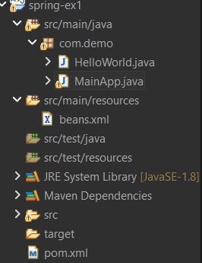

package com.demo;

public class HelloWorld {

private String message;

public void setMessage(String message) {
this.message = message;
}

public void getMessage() {
System.out.println("Message: " + message);
}
}
package com.demo;

import org.springframework.context.ApplicationContext;
import org.springframework.context.support.ClassPathXmlApplicationContext;

public class MainApp {

public static void main(String[] args) {

ApplicationContext context =
new ClassPathXmlApplicationContext("beans.xml");

HelloWorld obj = (HelloWorld) context.getBean("helloWorld");
obj.getMessage();
}}

<beans xmlns="http://www.springframework.org/schema/beans"
xmlns:xsi="http://www.w3.org/2001/XMLSchema-instance"
xsi:schemaLocation="http://www.springframework.org/schema/beans
http://www.springframework.org/schema/beans/spring-beans.xsd">

<bean id="helloWorld" class="com.demo.HelloWorld">
<property name="message" value="Hello Spring from Eclipse"/>
</bean>

</beans>

Pom.xml
<project xmlns="http://maven.apache.org/POM/4.0.0"
xmlns:xsi="http://www.w3.org/2001/XMLSchema-instance"
xsi:schemaLocation="http://maven.apache.org/POM/4.0.0 http://maven.apache.org/xsd/maven-4.0.0.xsd">
<modelVersion>4.0.0</modelVersion>
<groupId>com.demo</groupId>
<artifactId>spring-ex1</artifactId>
<version>0.0.1-SNAPSHOT</version>
<dependencies>

<!-- Spring Core -->
<dependency>
<groupId>org.springframework</groupId>
<artifactId>spring-context</artifactId>
<version>5.3.9</version>
</dependency>

</dependencies>
</project>

OUTPUT:
